
School of Tech
Bachelor of Business Information Management Cover Sheet and Student Declaration
This sheet must be signed by the student and attached to the submitted assessment.

Course Title: | Capstone Project (DA) | Course code: | BBIM713
Student Name: | SHIVAM | Student ID: | 764707237
Assessment No & Type: | Assessment 2, Research Project Report | Cohort: | BBIM7124C
Git Hub Repository | https://github.com/shivamverma1843/hmda-insights-hub
Due Date: | 1 November,2026 | Date  Submitted: | 1 November,2026
Tutor’s Name: | Sara
Assessment  Weighting | 65%
Total Marks | 100
Student Declaration:
I declare that:
- I have read the New Zealand School of Education Ltd policies and regulations on assessments and understand what plagiarism is.
- I am aware of the penalties for cheating and plagiarism as laid down by the New Zealand School of Education Ltd.
- This is an original assessment and is entirely my own work.
- Where I have quoted or made use of the ideas of other writers, I have acknowledged the source.
- This assessment has been prepared exclusively for this course and has not been or will not be submitted as assessed work in any other course.
- It has been explained to me that this assessment may be used by NZSE Ltd, for internal and/or external moderation.
Student signature: Shivam
Date: 1 November, 2026
Assessor only to complete:
Assessment results:
Assessment results: | Total Marks: /100
LO1 Requirements | Met ☐  Not Met ☐ | Assessor Signature
LO2 Requirements | Met ☐  Not Met ☐ | Assessor Signature
LO3 Requirements | Met ☐  Not Met ☐ | Assessor Signature

LO4 Requirements | Met ☐  Not Met ☐ | Assessor Signature
LO5 Requirements | Met ☐  Not Met ☐ | Assessor Signature

Contents
Abstract: 3
Project Question: 6
Project Development: 7
Training the Four Models 10
Project Design 18
Individual Reflection: 20
Discussion: 20
Challenges: 20
Limitations: 21
Conclusion and Future Directions: 21

Abstract:
This project developed and deployed a data analytics application to the developer of structural design tools for the single-family home (Nodey) to help them identify where they can expect site-built, owner-occupied, single-family housing to increase in value and where it will likely continue to grow. Millions of records are each year contained in different files of the Home Mortgage Disclosure Act (HMDA) Snapshot National Loan-Level Dataset, making market analysis challenging. The 2017 file was not included because there are no column names in the file, and the analysis is conducted for 2018–2025. Using project management techniques, such as a 16-week project plan, milestones and the combined checking of the results, a two-person team downloaded, cleaned, filtered and aggregated 18 key fields into summarized tables of various length and width.
Key findings include a median site-built property value increase of approximately 30% since 2018, an annual increase of approximately 2% since 2018 and purchase originations declining from approximately 10 million in 2021 to 4.6 million in 2025.
Boise City had the fastest annual growth rate (about 11%) compared to the country's 3.8%. Site-built homes are 3.6 times more expensive than manufactured homes ($455K v. $126K in 2025) but this is trending towards narrowing down slowly. Approximately 10% were rejected with the lowest rate in 2021 and highest around 2023. Moderate growth to 2028 as represented by ranges.
We does not have much confidence in the results provided by Power BI because it could not reliably handle the file sizes and provided different results to the custom dashboard, and therefore recommends using the custom dashboard. Some of the drawbacks are that HMDA only includes purchases with mortgages, it does not demonstrate association with causation, and it lacks any default outcomes.

Keywords
HMDA; Housing market analytics; Property value forecasting; Business intelligence dashboard; Site-built and manufactured housing; Mortgage lending patterns

Introduction
This topic introduces to the main theme of the course.
The nature of housing market conditions varies state to state and metro to metro due to variations in economic and population growth, housing demand and mortgage lending. This is why it is crucial to have accurate and current market intelligence that helps with making good decisions and investments. The Home Mortgage Disclosure Act (HMDA) Snapshot National Loan-Level Dataset (2017 to 2025) is a great resource for analysts who wish to perform analyses on the housing market over time. Published by the Federal Financial Institutions Examination Council (FFIEC), it contains the geographic, property value, loan, applicant income and construction method data for approximately 10 million records.
1.2 Industry Context and Project Problem:
This is an industry project in collaboration with developer of structural design and engineering tools for residential housing, Nodey. Nodey requires data and insight to better understand site-built, owner-occupied, single-family housing markets and their relative change by region to manufactured housing.
Problem:
The HMDA data is very large and contains millions of records representing loan-level information, which have been placed in different year-end data files, making it difficult to draw insight from the data using traditional reporting methods. Consequently, enterprises have difficulty in finding markets that are considered to have good growth potentials, comparing their performances with other regions, monitoring the mortgage lending trend, and predicting future opportunities. The data also had to be preprocessed to handle missing or exempt data, inconsistent formats, as well as duplicate data and inconsistencies with data types. The challenge, then, is to transform the vast amount of mortgage information into business intelligence via an integrated solution.
To be able to answer questions related to the project and make it relevant.
The primary business issue is, where is there growth in site-built housing and where might there be future growth opportunities? It is supported by 5 questions:
2. Are the number of site-built home purchase loans UP or DOWN and the median value of property?
2. What states and metros had the biggest gain in real estate values?
3. Does there exist any difference between the growth of value between site built homes and manufactured homes?
What is the correlation between loan denials and growth in property values?
6. What will be the strongest markets in the next 2 – 3 years?
The scope is HMDA data for the period 2017–2025, and is primarily for site-built owner-occupied, single-family home. The intention was to utilize this information to identify housing market trends, quantify regional growth, identify lending trends and predict the value of properties. The MVP delivered a custom AI-assisted web dashboard (in Base44) with filters, maps and rankings, which meets the client's needs to deliver a custom analysis, as well as a Power BI analysis dashboard for a comparative business intelligence solution.
1.4 Rationale and Gap
The studies of house price prediction and spatial effects examined the housing goods but did not focus on manufactured housing. A study of house price prediction was conducted by Sharma et al. (2024) and another study on spatial effects was conducted by Hu et al. (2022). Also, previous studies included a study by Wheeler & Olson (2015) on mortgage denial patterns and a study by Herbert et al. (2023) on the difference between site-built and manufactured housing. Each does however focus on a single theme, and government reports are primarily descriptive of giving out loans, not prediction or interaction. There is no data that merges property values, lender outcomes, and housing type and forecasting into a single decision-support tool from the HMDA data set. This project will fill that gap.
1.5 Team Member Responsibilities
Two members of the project team worked on the project. Team Member 1 downloaded and cleaned the data for the period 2017-2021, performed exploratory data analysis, data integration, created the forecasting models and composed the literature review. Team Member 2 downloaded and cleaned the dataset for 2022 - 2025, and developed the web application and dashboards, as well as the documentation and final report. They collaborated and worked together to answer the business questions, combined datasets, validated the results of the analysis and created the presentation.

Project Question:
The approved central business challenge is: Where is the market for site built homes growing and where are there opportunities for Nodey in the future?

Question 1 (market size and value trend): Have the number of site-built, owner-occupied, single-family home-purchase loans increased or decreased annually from 2017 to 2025 and how has the median value of the properties changed annually from 2017 to 2025?

Question 2: (geography of growth) What is the median value of the fastest growing metros and the fastest growing states, respectively, and what is the difference (in compound annual growth rate) between the fastest growing and slowest?
Question 3 (site-built versus manufactured): Is the difference in growth in value between manufactured and site-built homes greater than some other level of significance and is that difference growing larger or smaller over time?

In high growth markets, is denial rate for home-purchase loans correlated with value growth and is tighter credit correlated with before, during or after the highest growth? Lending is not considered a cause, just a supporting indicator.
Forecasting: At the National, State and selected metro level which markets will have the highest dollar increases in the next 2-3 years?

The scope of the project will remain as the proposed project using the 2017-2025 HMDA data, and will be used for primarily owner-occupied, single-family, site-built homes. There are no default probabilities provided in the data and so the scope of default probability prediction is not applicable.

Complexity: The complexity of the needs is a consequence of the need to combine nine years of millions of loan level data points, the need to handle missing or exempt values, the need to compare results with geographic levels, the need to analyse the results over time and to produce forecasts. They should be displayed in interactive dashboards and custom application as well with Power BI.

Project Development:
All coding screenshot and descriptions:
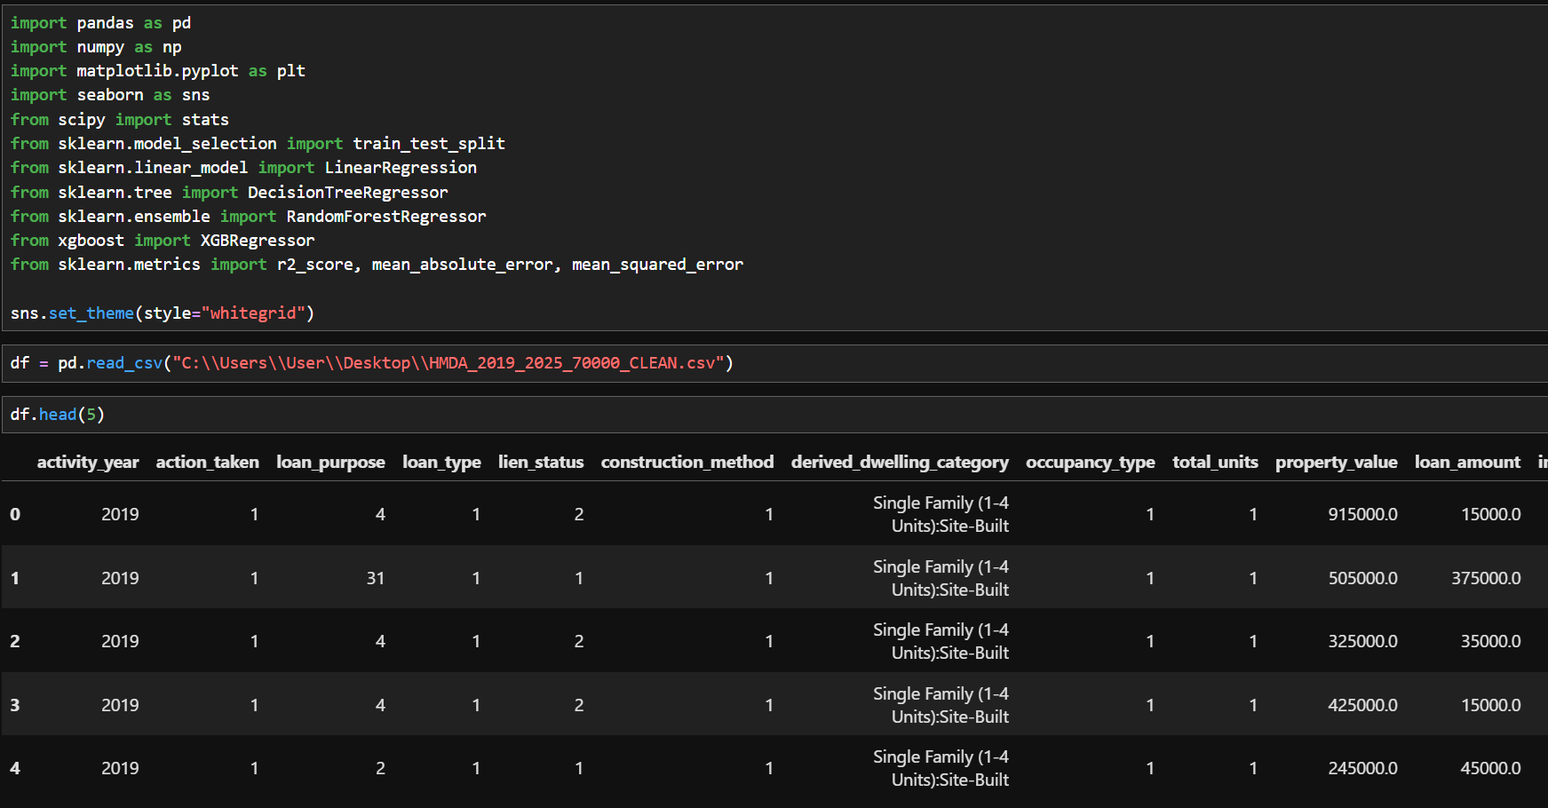
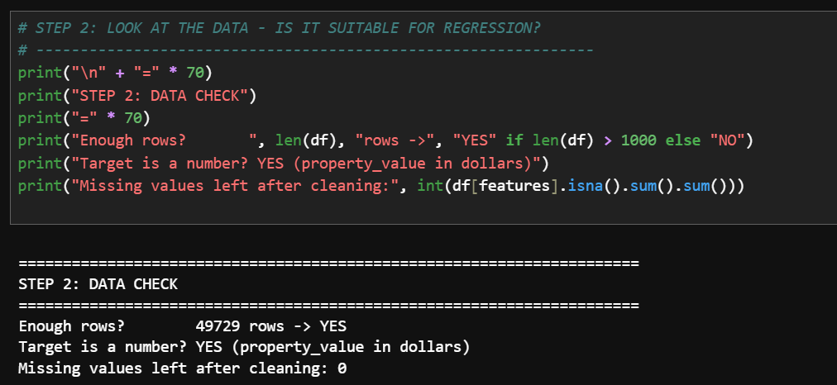
3.1 Data check
What the code does. This short block prints out a checklist prior to constructing anything. It asks three questions: No. of rows: is there any more than 1,000 rows of data in your file? (We need more than 1,000 rows for it to work.No. of rows: does your file have more than 1,000 rows? (It requires more than 1,000 rows of data in your file. What it shows. The number of rows is 49,729, that's quite a lot. Target number is a dollar amount. So far, there are no missing values. Thus, the answer to the question is: YES, the data is ready for regression.
3.2 Graph 1: How are home prices spread out?
The code changes prices into thousands of dollars so they are easier to read. Then it works out the median, the average, the 25th percentile and the 75th percentile and the percentage of houses valued at more than $1.5 million. It then creates a graph called a histogram, in which each bar has a count of the homes that are priced in a $50,000 range. The median is shown as a red line, the average as a blue dashed line and the middle 50% as a yellow band.
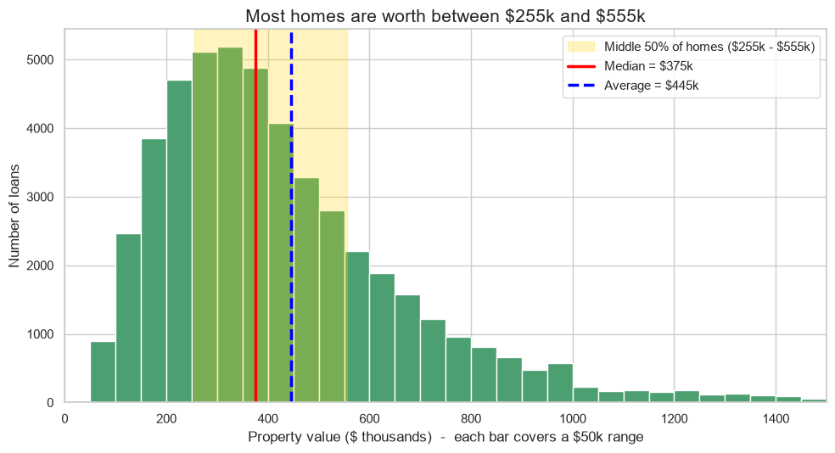
The graph represents. Most homes fall into the lower and middle bars of the diagram, which are the tallest bars, on the left hand side of the diagram. Half of the homeowners' houses are more expensive than the $375k median and half sell for less. The average (AVG) is $445k, and is skewed to the right of the median by a few very expensive homes. The yellow band indicates the typical range, or the middle 50% of houses fall into this price range, between $255k and $555k. A long tail to the right as shown in the graph, which is considered as right skewed means that there are many homes that are affordable and few very expensive homes. The number of homes above $1.5 million is small (only 1.4%) and not included in this chart.
3.3 Graph 2: Correlation matrix (which columns are linked
The code determines the strength of the association between each pair of columns with the Spearman measure and visualizes the results in a colourful matrix called a heatmap. Spearman considers the order (rank) of the values, and is therefore suitable data even if it is skewed, as in the case of our prices. Each square contains a number that can be +1, -1 or any number in between. Numbers around +1 (red) indicate that the two columns go up and down in unison. Numbers close to 0 (pale) indicate that there is no link. If a number is close to -1 (blue), then the other number will increase, while the blue one will decrease.
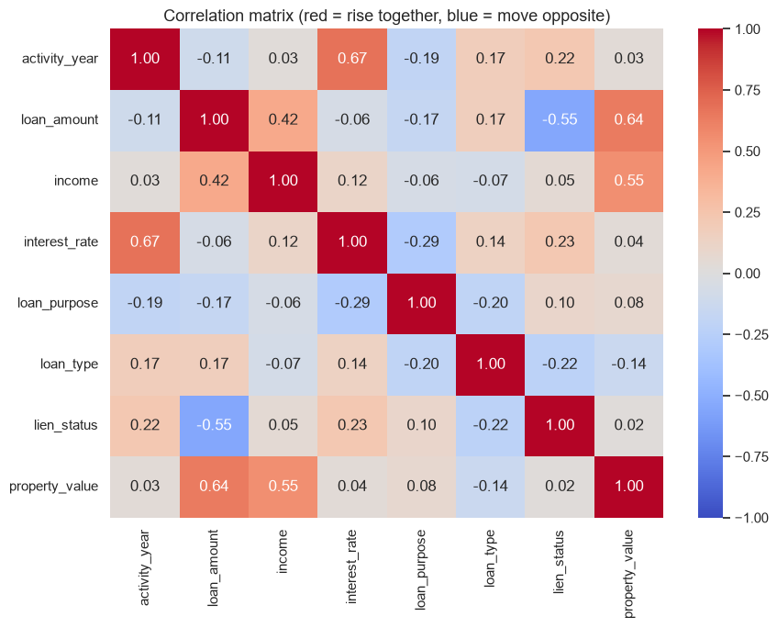
The graph indicates that. Examine last row or column, property_value. There are strong relationships between loan amount (0.64) and income (0.55) and property value. That larger loans and higher wages is related to larger homes. On their own, year (0.03), interest rate (0.04), loan purpose (0.08) and lien status (0.02) are almost unrelated to price, and loan type is slightly negative (-0.14). Also, some links between the inputs themselves are indicated in the grid. Such as year and interest rate (0.67) and loan amount and lien status (-0.55), for instance, where the change in interest rate over the years makes sense and the lien status of the loan and its amount make sense.
Conclusion. Since the data is not purely random, it is appropriate to use regression. One reminder to the class: Just because there's a connection between two columns doesn't mean that one caused the other.

4. Training the Four Models
4.1 What the main code does
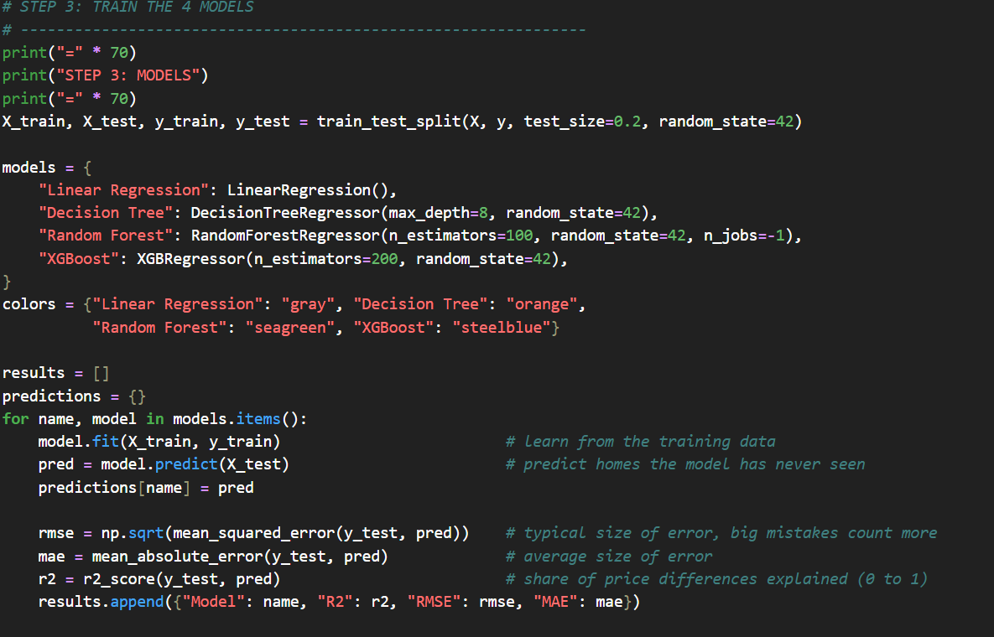 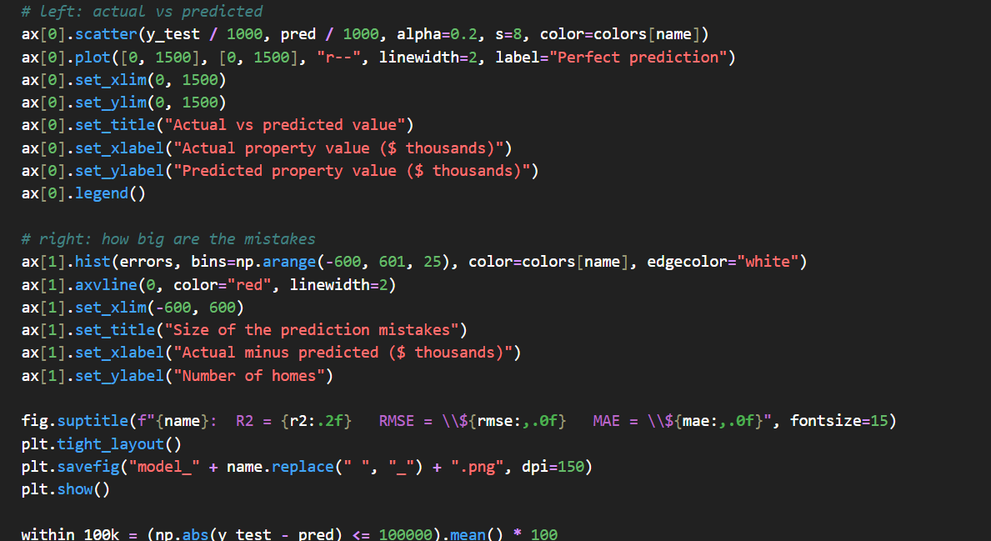
The code performs a loop for each model. It is applied to the model on the training houses, then forecasts the price of the test houses and finally calculates three scores. R2 will tell us how much of the differences in price are accounted for by the model (0-1), with higher numbers being better. The size of the error in dollars is the typical size of the error, with large errors counting more, and lower is better, for RMSE. The lower, the better, MAE is the average dollar error. The code also calculates the number of predictions that were within $100,000 from the actual price.T

4.2 Model 1: Linear Regression
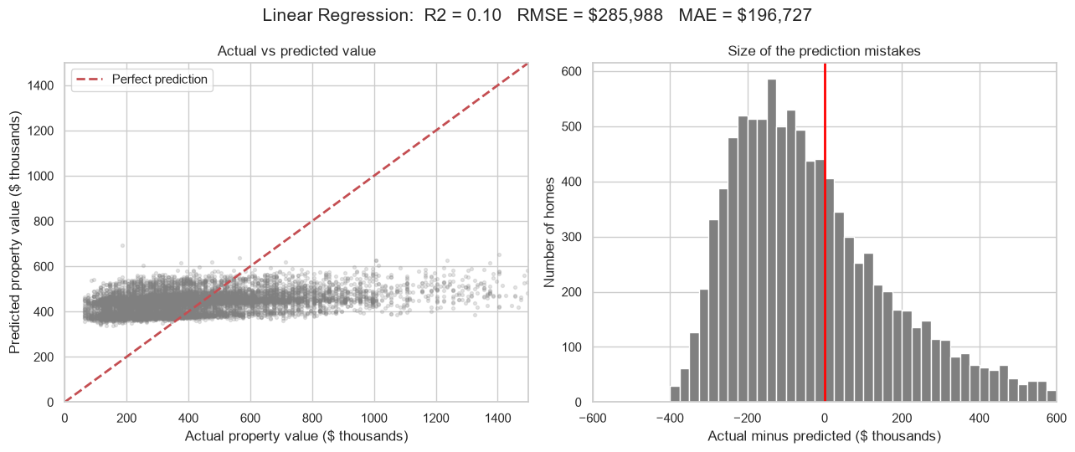
The R2 value of Linear Regression is 0.10, which means that 10% of the differences in the values of the homes are accounted for by the Linear Regression. The typical mistake (RMSE) is $285,988, the average mistake (MAE) is $196,727, and only 32% of the forecasted prices are within $100,000 of the actual price. As you can see on the left chart there is no correlation between the dots and the red line. They basically create a flat band around $400k for almost all homes, as the model provides almost the same response. On the right chart the errors are distributed broadly there are lots of large errors.

Model 2: Decision Tree
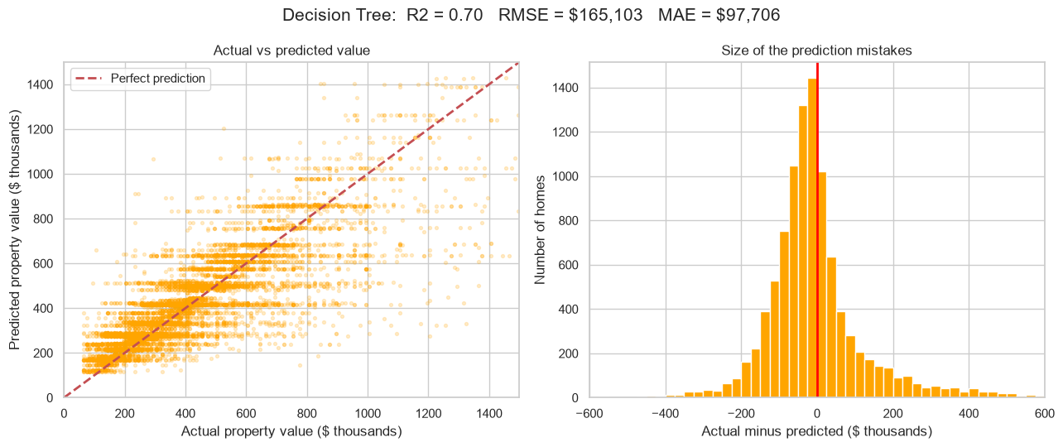

The R2 of the Decision Tree is 0.70, which means that it accounts for 70% of the variability in home values. Its RMSE is $165,103, its MAE is $97,706, and 69% of its predictions are within $100,000. The dots are now closer to the red line in the chart on the left. The errors are concentrated at the centre of the chart on the right; this indicates that there are a lot of small errors. A significant step beyond Linear Regression that demonstrated that home values are curves and combinations, and not a line.
Model 3: Random Forest
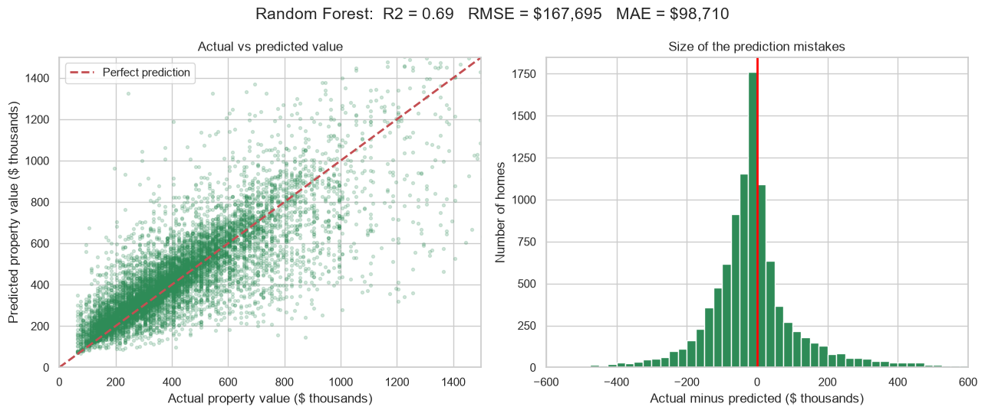

The Random Forest has an R2 of 0.69, an RMSE of $167,695 and an MAE of $98,710, and 68% of its predictions are within $100,000. The charts are similar to the Decision Tree. The dots remain close to the red line for most houses and the errors are grouped in the centre of the zero mark. The forest is not better than this single tree, but typically more stable due to averaging multiple trees.
Model 4: XGBoost
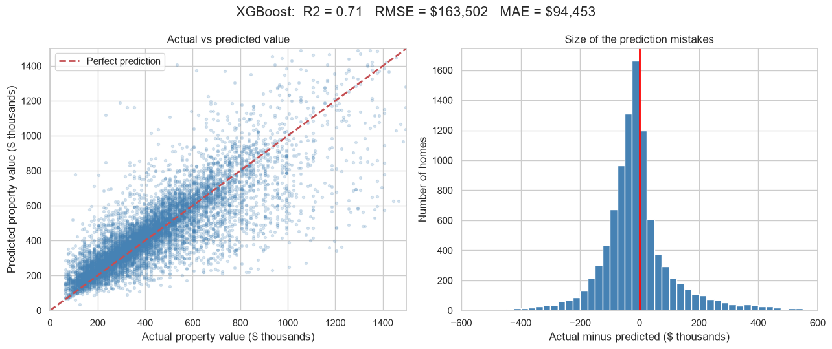
XGBoost has the best scores: an R2 of 0.71, an RMSE of $163,502 and an MAE of $94,453, and 71% of its predictions are within $100,000. The dots are tightly clustered around the red line on the left chart; they are stacked above and below the zero with many mistakes on the right chart. This is similar to the other models, in that it gets the errors larger for the most costly homes on the right half of the chart.
4.6 Which inputs matter most?
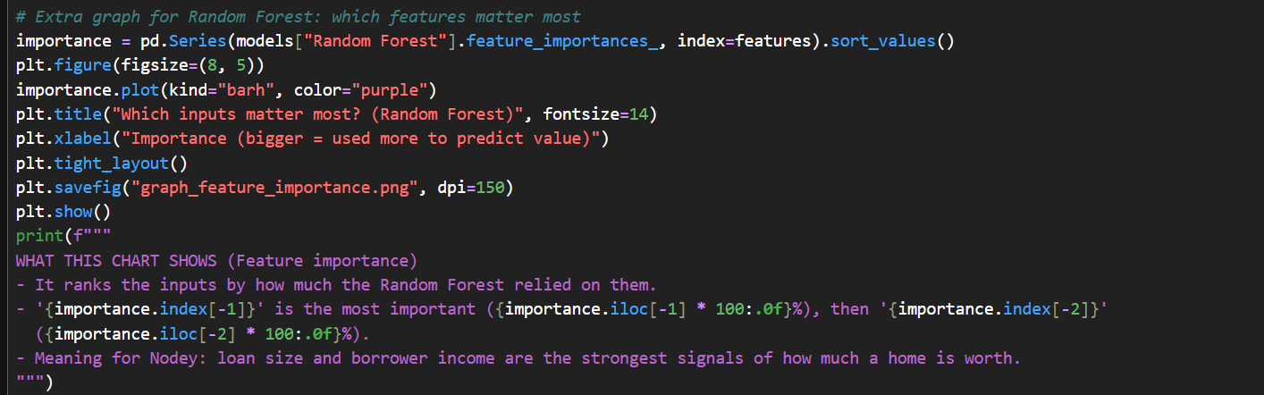
The Random Forest keeps a record of how much it used each input while building its trees. The code reads this record, sorts it from smallest to biggest, and draws a horizontal bar chart. A longer bar means the model relied on that input more to guess the price.
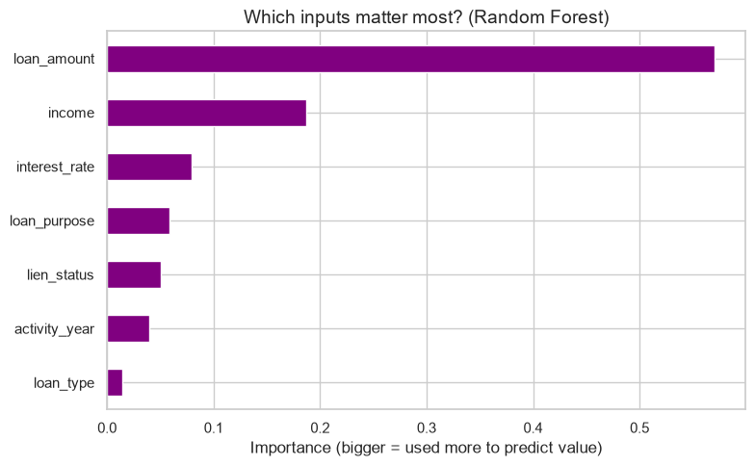
loan amount is by far the most important input at about 57%, followed by income at about 19%. The other inputs are much smaller: interest rate is roughly 8%, loan purpose about 6%, lien status about 5%, year about 4%, and loan type about 1%. This matches the correlation graph, where loan amount and income were also the strongest.

5. Comparison of all models:
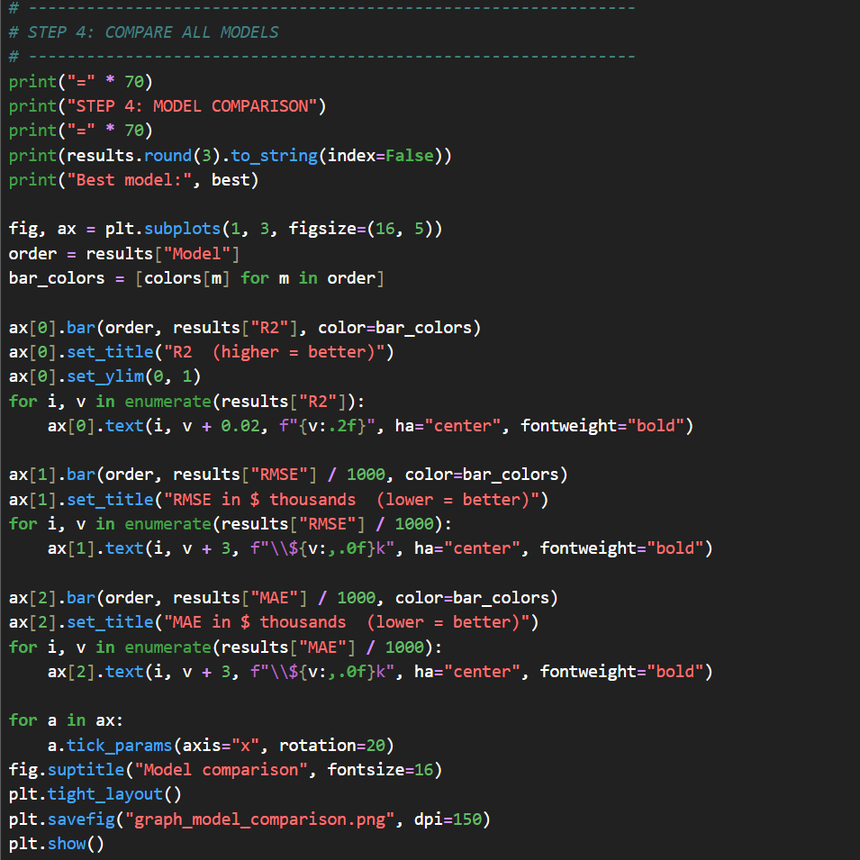

This block displays a table containing the results and sorts them from best to worst R2 and names the best model. It then displays three side by side bar charts for R2, RMSE and MAE values respectively for the same color applied to each model.

Model | R2 | RMSE | MAE | Within $100k
XGBoost | 0.71 | $163,502 | $94,453 | 71%
Decision Tree | 0.70 | $165,103 | $97,706 | 69%
Random Forest | 0.69 | $167,695 | $98,710 | 68%
Linear Regression | 0.10 | $285,988 | $196,727 | 32%
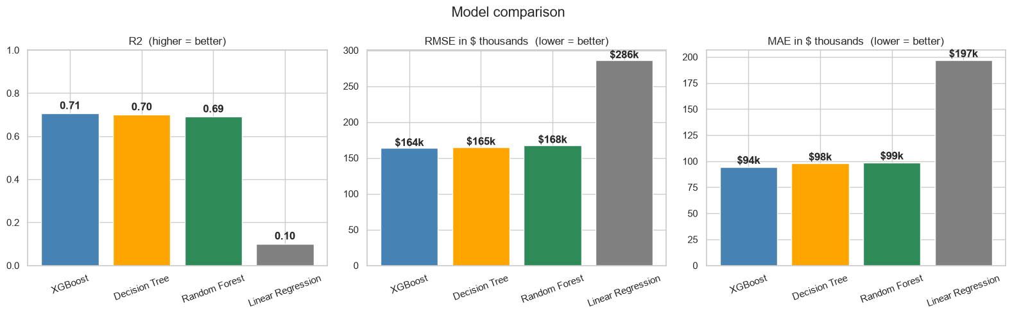
All three charts show the same trend, and were taken on the same test homes. The best performance in terms of R2 (left, higher is better) is achieved by XGBoost at 0.71 and the worst performance is achieved by Linear Regression at 0.10. The lower the value, the better on both RMSE (middle) and MAE (right). The average error for XGBoost is around $94,453 while Linear Regression is around $196,727, which is more than twice the error. Linear Regression is out because home values don’t seem to be a linear function of loan size and income. They're all very skewed, and the bigger the price, the more it can be incorrect. Tree-based models can be used for curves and combinations.

5.2 All models on one picture
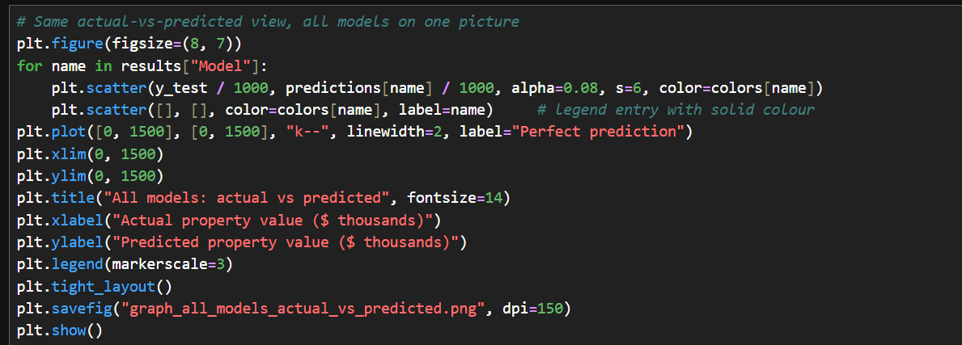

This code puts the predictions of all four models on a single actual-vs-predicted chart. Each model has its own color, and the black dashed line is perfect prediction

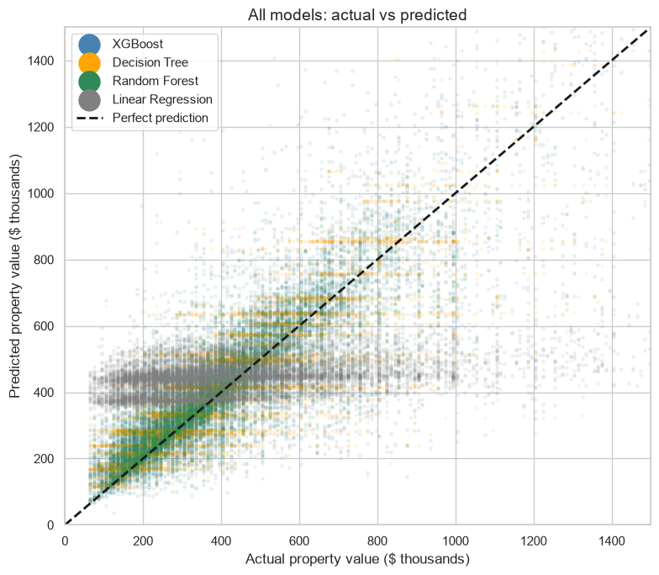
The grey dots (Linear Regression) are on a flat band. The model estimates approximately the same dollar amount ($400k) for nearly all homes, which is why it fails to capture the cheaper homes as well as the more expensive ones. The orange, green and blue dots (the tree models) remain fairly close to the black line. For every model, the dots are more dispersed towards the right side, which implies that the most costly homes are the toughest to anticipate.
Fastest and Slowest Growing Areas

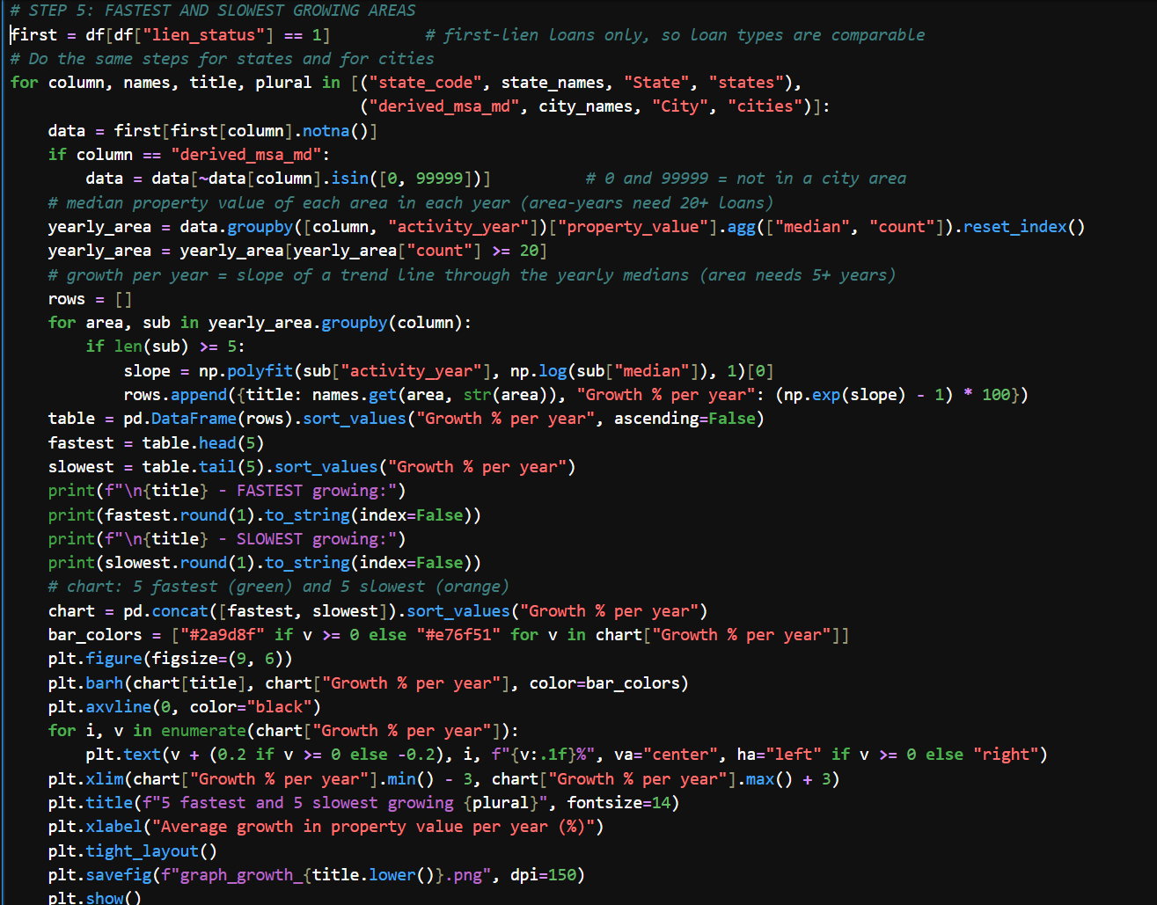

How growth is measured. The methods used to determine the extent of growth. The code employs only first lien loans, and types of loans are similar. For cities it excludes the code 99999 (not in a city area) and the code 0 (not in a city area). It determines the median property value for each place and for each year, and only saves the place-years with at least 20 loans. At least 5 years of data is required to include a place. Then it makes a graph of a trend line connecting the yearly values of each place.
Graph: States
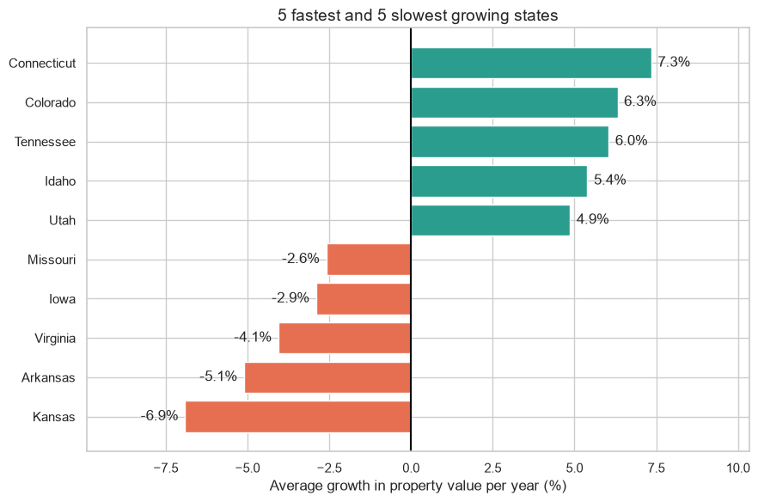

What the graph shows.
The fastest growing states are Connecticut (7.3% a year), Colorado (6.3%), Tennessee (6.0%), Idaho (5.4%) and Utah (4.9%). The slowest are Kansas (-6.9% a year), Arkansas (-5.1%), Virginia (-4.1%), Iowa (-2.9%) and Missouri (-2.6%). Growth refers to the average increase in the median property value over a period of five years (from 2019 to 2025).
6.3 Graph: Cities
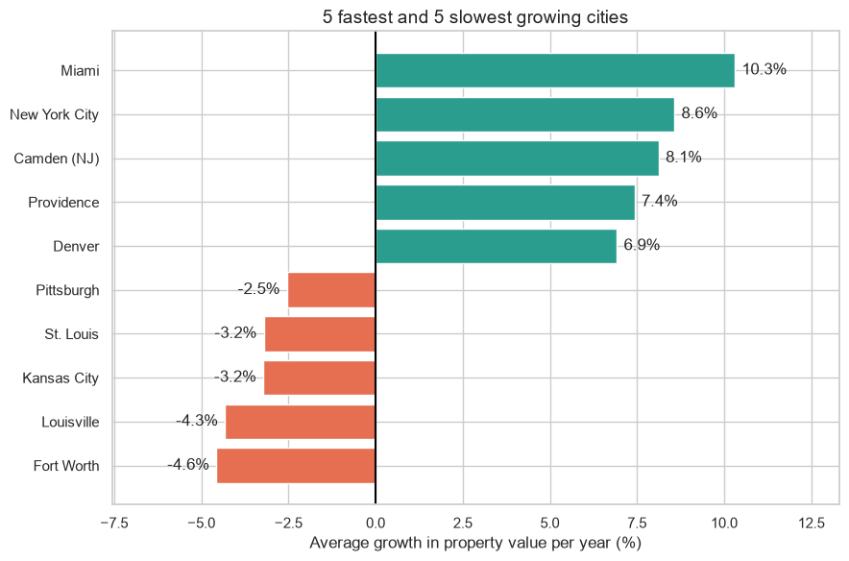

The fastest growing states are Connecticut (7.3% a year), Colorado (6.3%), Tennessee (6.0%), Idaho (5.4%) and Utah (4.9%). The slowest are Kansas (-6.9% a year), Arkansas (-5.1%), Virginia (-4.1%), Iowa (-2.9%) and Missouri (-2.6%). Growth refers to the average increase in the median property value over a period of five years (from 2019 to 2025).
Time Series and 3-Year Forecast
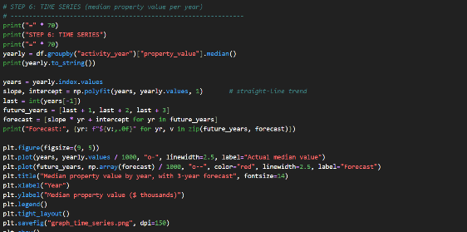

The code identifies the median value for each year and draws a straight trend line through each of the values identified and then extends it down 3 years. This gives a simple forecast for 2026, 2027 and 2028. The yearly medians are: 2019 $395k, 2020 $445k, 2021 $235k, 2022 $385k, 2023 $375k, 2024 $395k and 2025 $405k.
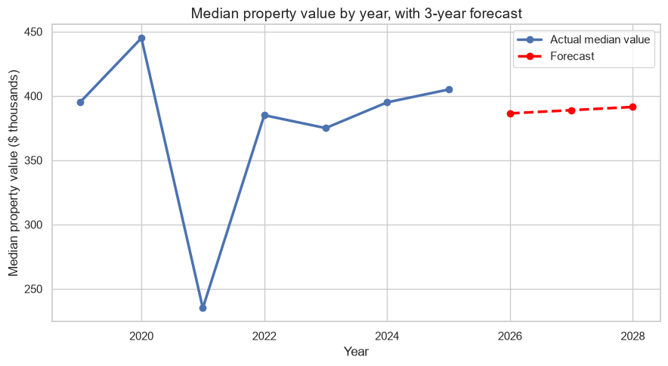
The actual median value for each year is shown on the blue line with dots. The red dashed line is the forecast: about $386,429 in 2026, $388,929 in 2027 and $391,429 in 2028, which is a rise of about $2,500 a year. This is the steep drop in 2021 to $235k that is most distinct about the blue line.

Project Design
Ques 4.
Solution Design: The design phase is the blueprint for the solution. Figure 1 (the schematic diagram) shows how each module connects, from the raw HMDA files to the dashboards.
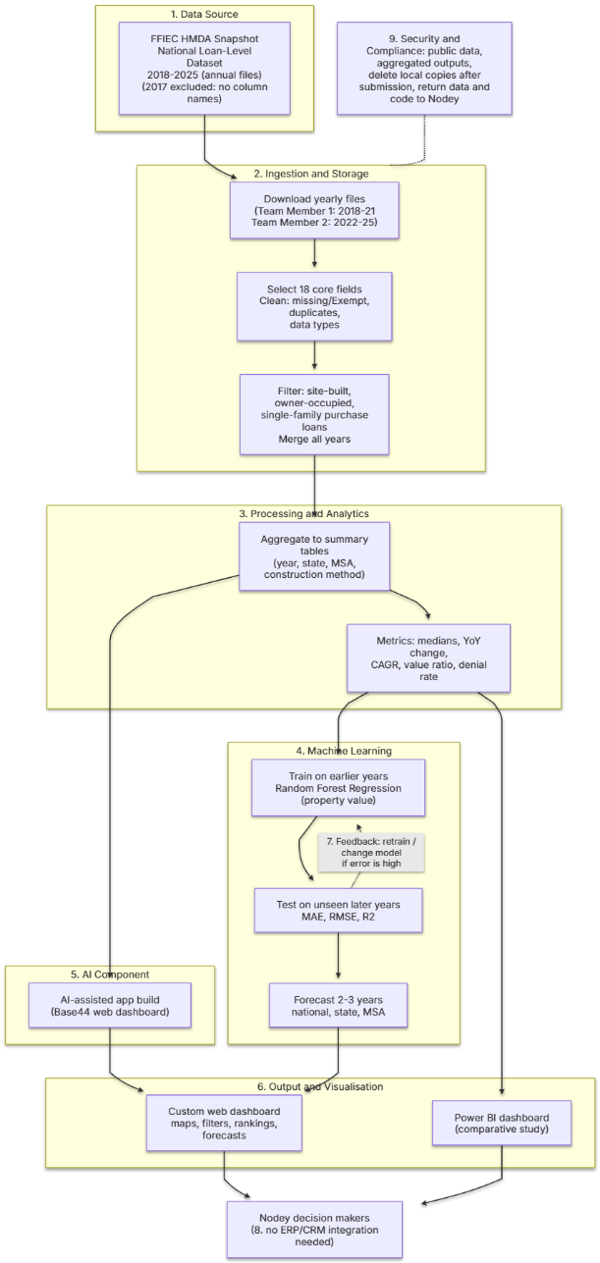
4.1 Data Sources. The only source is the FFIEC HMDA Snapshot National Loan-Level Dataset, published as one file per year for 2017 to 2025. It is public, regulated data from lenders across the United States. The project uses 18 core fields, including property value, loan amount, construction method, occupancy type, state, county, metro area and action taken.
4.2 Data Ingestion and Storage. The two team members downloaded the yearly files, with Team Member 1 taking 2017 to 2021 and Team Member 2 taking 2022 to 2025. Each file was reduced to the 18 core fields, then cleaned for missing or “Exempt” values, duplicates, inconsistent formats and data type problems. The data was filtered to site-built, owner-occupied, single-family purchase loans, with manufactured homes kept for comparison. All years were then merged into one dataset.
4.3 Data Processing and Analytics. The merged data was aggregated into small summary tables by year, state, metro area and construction method. The processing is batch, because HMDA is published annually. The tables hold the metrics for each business question: median property value, year-over-year change, compound annual growth rate (CAGR), the site-built to manufactured value ratio, origination counts and denial rates. Summary tables also solved a practical problem. Power BI could not combine the full files, whereas small tables load completely and can be checked.
4.4 Machine Learning Models. The proposal selected Random Forest Regression to predict property value. It handles large, structured data, captures non-linear relationships and reports feature importance. Inputs are activity year, loan amount, income, interest rate, construction method, occupancy type, units, state, county, metro area, loan purpose, loan type and lien status. Performance is measured with MAE, RMSE and R². Linear Regression, XGBoost, and Logistic Regression were considered. The model’s forecasts for the next two to three years feed the dashboard as ranges, not single promises.
4.5 AI Components. AI is used in building the solution, not in the data. The custom web dashboard was built with the AI app builder Base44, which produced filters, maps and ranking views from the summary tables. No natural language or signal processing is used, because the data is structured and tabular.
4.6 Output and Visualisation. There are two outputs. The first is the custom web dashboard with year filters, a state map, a ranking of the fastest-growing metros, the site-built versus manufactured comparison, the denial rate view and the forecast. The second is a Power BI dashboard covering the same questions, used for the comparative study.
4.7 Feedback Loop. Models are trained on earlier years and tested on later years they have not seen. If error is high, the model or its inputs are changed and retested. Once a new HMDA year is published, the same cycle can be repeated.
4.8 Integration Points. No ERP or CRM integration is needed. The dashboard is a standalone tool for Novey’s strategy team, reading from the prepared summary tables.
4.9 Security and Compliance. HMDA data is public, and the outputs are aggregated, so no individual is identified. Ethics approval for the stored dataset is [insert approval reference]. Local copies of the data will be deleted from the team’s devices after capstone submission, and the data and source code will be returned to Nodey as instructed.
Individual Reflection:
This included preparing the 2018-2025 HMDA files, developing the dashboards and documenting the work. This reflection focuses on the portions of the design and development.

Discussion:
The design in Figure 1 passed the data through the process of cleaning, aggregation, forecasting and dashboards. The major design decision was to do aggregations early. There are millions of rows for each of the 18 different data files annually, so I narrowed the data down to only include loans for site-built, owner-occupied, single-family purchase cases and then summed them by year, state, metro area and construction method. This entails coding up scripts to read each file, remove the missing or “Exempt” values, correct data types, calculate medians, year over year change, CAGR, value ratios and denial rates, and export small tables during the coding phase.

Challenges:
The first problem was the quality of data. The 2017 file, with no identifiably named columns, was not included in the team's data. This thus gave me eight years, which I will take, as a compromise; if I had tried to guess the column, I might have gotten the answers wrong on each of the nine questions. The medians for other fields are approximate due to the fields that contain ‘Exempt' and ‘NA' or have been rounded to the nearest $10,000.

The second challenge was Power BI – which I created myself. They were very large files, and took a long time to load so I wasn't sure if all the data had loaded or if all the numbers were correct. The numbers did not match those on the Base44 dashboard, and I was not able to determine which ones were correct. This was exacerbated by changing the data set. Adding a new column or value was very time consuming every time, and some were even incorrect, so it wasn't possible to correct a problem and re-check it. Power BI wasn't a validation tool for me because of the results and not due to confidence in it.I have low confidence in Power BI because I couldn't justify the results.

To do this competently I had to learn a few things: Knowledge gaps (new paragraph). I had to grasp the meaning of the words used in the HMDA definitions and codes, such as in the construction method, who occupied, and what action was taken. I wanted to be able to use techniques for reading in files that were too big to fit in memory (reading in chunks, filtering early, etc.). To learn to test and check AI generated apps, and how Power BI deals with large data imports, refreshes when changes are made to a dataset and calculated measures. Also, I wanted to learn how to assess forecasts in unseen years so that I could put a proper range on the forecasts.

Limitations:
There are several limitations to the project. Because only mortgage-financed transactions are recorded in HMDA, only the results from these transactions are reported and do not reflect the entire housing market. Denial rates can be correlated with price increases but not proved to be a cause. Unlike the original proposal, the data does not have “default” outcomes, so the original proposal for default probability was not possible to predict. The forecasts are ranges and not guarantees and are based on historical trends only and may be impacted by interest rates and/or policy or economic shocks.

Conclusion and Future Directions:
This project created an analytics solution for Nodey to document the areas of growth for site-built, owner occupied, single-family housing and to identify where it could grow in the future. The team cleaned & summarized millions of records on the transaction level for the HMDA data for the years 2018-2025; predicted these data; and developed a custom web dashboard and a Power BI dashboard for comparison. My part consisted of building the building's dashboards and wrote the documentation. I also collaborated in the group effort for setting up the business questions, amalgamated data and checked accuracy.

The key results and achievements:
The median site-built property value has increased by around 30% since 2018, but has slowed to around 2% compound annual growth rate, and purchase originations have dropped from around 10 million in 2021 to around 4.6 million in 2025. The fastest growth was in Boise City with an annual growth rate of 11.4% compared to the 3.8% national growth rate, while Phoenix, Nashville, and Raleigh were among the fastest growing cities in the country. The price difference between site-built and manufactured homes is still very significant, but it is closing at a slow pace with site-built homes at $455K and manufactured at $126K for 2025. Approximately 10% of loans were rejected, with the least number of rejections in 2021 and the most between about 2023. Future (2028) projections indicate moderate growth in the future, but are expressed as ranges. The biggest success was the creation of a working tool that provides answers to all five business questions in the form of filters, a map and rankings that Nodey didn't have before.
The practical implications and recommendations are put forward.
The market selection factor is more important than the national demand, says Nodey, given the slow growth rate and steep drop in purchase volume in the country. All of the above may be suitable candidates for product focus, but metros like Boise City and Phoenix, Nashville and Raleigh, are good first choices and the extreme reductions in price differentials with manufactured housing are intriguing.

Recommendations:
The first thing that Nodey should do is install the custom dashboard as it loads all the small summary tables completely and each number can be traced and checked. Second, Power BI shouldn't be used until re-built on the summary tables and the results are consistent with the custom dashboard. Third, forecasts need to be interpreted as ranges and updated whenever a new HMDA year comes out. Fourth, in the future, key figures need to be controlled in the source data.

Unique contribution
Property values, housing type and mortgage lending and forecasting are being tackled in one decision support system, whereas previous studies have concentrated on only one of the three themes. It also shows how to work with big public datasets: it parses this down to a list of validations that are then transformed into summary tables that then are used by the builder with AI assistance to build the app quicker. The comparison with power-BI highlights a true constraint of the common approaches to working with raw loan level files for which other teams can learn. The potential impact is quicker, evidence-based market selection for a construction technology company, with only free public data.
The future of the project and directions. There are several concerns. Housing markets can change rapidly over time due to changes in interest rates, inflation, or policy and local economic shocks that can also affect the accuracy of forecasts. The data in the 2017 file can be recovered using the published HMDA data dictionary, thereby adding one year to the series. A few data quality issues will persist (rounded values, missing entries), lending data will include some bias (which should be considered when interpreting denial rates).
References:
Herbert, C., Reed, C., & Shen, J. (2023, July). Comparison of the costs of manufactured and site-built housing. Harvard Joint Center for Housing Studies.
Hu, L., Chun, Y., & Griffith, D. A. (2022). Incorporating spatial autocorrelation into house sale price prediction using random forest model. Transactions in GIS, 26(5), 2123–2144. https://doi.org/10.1111/tgis.12931
Sharma, H., Harsora, H., & Ogunleye, B. (2024). An optimal house price prediction algorithm: XGBoost. Data, 3(1), Article 3. https://doi.org/10.3390/data3010003
Wheeler, C. H., & Olson, L. M. (2015). Racial differences in mortgage denials over the housing cycle: Evidence from U.S. metropolitan areas. Journal of Housing Economics, 30, 23–38. https://doi.org/10.1016/j.jhe.2015.09.001

Git Hub Repository: https://github.com/shivamverma1843/hmda-insights-hub
Datasets Source: https://ffiec.cfpb.gov/data-publication/snapshot-national-loan-level-dataset/2025

Appendix 4: Checkpoint Checklist #__

Purpose
This checklist ensures that a selected Capstone Project is progressing as intended for the student and business organisation. The Checklist will be completed by the NZSE Capstone Project Leader in conjunction with the student and the Capstone Project Supervisors.

Criteria | Yes/No | Initials
Are the student and Capstone Project Supervisors free from any performance or other issues? If no, please comment below.
Have the Capstone Project Supervisors and student developed workbased expectations/goals for the Capstone Project period?
Does the student’s physical workplace remain suitable for the Capstone Project placement?
Does the student have a clear understanding of expectations required to complete the Capstone Project?
Has the student received input from their Capstone Project
Supervisors on how to complete any required reports/assignments?
Have you asked for feedback on how to improve the placement? Please comment below.
Do you recommend continuing with the Capstone Project assignment?

Feedback from Student

Feedback from Capstone Project Supervisors

_____________________________ ____________________
Student Signature Date

_____________________________ ____________________
Capstone Project Supervisor(s) Signature Date

_____________________________ ____________________
NZSE Capstone Project Leader Signature Date
Appendix 5: Capstone Project Weekly Work Log
Between: Shivam, Sachita (Student Name) and Nodey (Name of Company)
Supervisors / Capstone Project Leader details, address and contact details: ______________________________
Hours Log
Date | Hours worked | Work done (itemized) | Student Initials
Week 1: | 19 | Reviewed client requirements with Nodey; defined project scope, aim, objectives and research questions; assigned team responsibilities. | SS
Week 2: | 19 | Conducted literature search (Scopus, IEEE Xplore, Google Scholar) on HMDA, housing forecasting and BI; began PRISMA screening. | SS
Week 3: | 15 | Completed literature review and critical review; identified research gaps; drafted PRISMA diagram. | SS
Week 4: | 20 | Developed project plan, work breakdown structure, Gantt chart, stakeholder communication plan, and team coordination strategy. | SS
Week 5: | 20 | Finalized abstract, keywords and proposal document; reviewed, formatted and submitted the Project Proposal (Assessment 1). | SS
Week 6: | 20 | Downloaded the yearly HMDA loan files (2018–2025) from FFIEC; reviewed file structure and data dictionary; found the 2017 file has no column names and excluded it; agreed how to split the cleaning (2018–2021 and 2022–2025); set up GitHub repository. | SS
Week 7: | 20 | Selected the columns needed; filtered to owner-occupied, site-built homes; started cleaning missing, inconsistent and incorrectly typed values; fortnightly meeting with Nodey to confirm data scope. | SS
Week 8: | 20 | Completed data cleaning and data-type checks; created the 70,000-loan sample for the notebook; built summary tables by year, state and city; checked totals against the raw files. | SS
Week 9: | 20 | Started the Python notebook: data validation checks and exploratory charts (prices, loan volumes, denial rates); weekly supervisor meeting; fortnightly meeting with Nodey to review progress. | SS
Week 10: | 20 | Built and trained the Linear Regression and Decision Tree price models; tested both on houses they had not seen; recorded score and typical error. | SS
Week 11: | 20 | Trained the Random Forest and XGBoost models; compared all four models (R², RMSE, MAE); analysed which inputs mattered most (loan amount and income); fortnightly meeting with Nodey. | SS
Week 12: | 20 | Worked out growth by state and city; built a simple 3-year forecast to 2028; started the custom Base44 dashboard; weekly supervisor meeting. | SS
Week 13: | 20 | Completed the Base44 dashboard (year filters, headline numbers, value map, Invest vs. Avoid summary, forecast); started the Power BI dashboard; fortnightly meeting with Nodey. | SS
Week 14: | 20 | Finished the Power BI dashboard; compared it with the Base44 dashboard and found the numbers did not match; checked dashboard figures against the summary tables; decided to recommend Base44; weekly supervisor meeting. | SS
Week 15: | 20 | Reviewed ethics against the Privacy Act 2020, Te Tiriti o Waitangi and Māori data, Algorithm Charter and professional codes; wrote problems, changes from the proposal, limits and next steps; started the portfolio website; fortnightly meeting with Nodey. | SS
Week 16: | 20 | Completed the portfolio and final report; tidied code, data and report folders; final edits and checks; final meeting with external supervisor (Nodey). | SS
Total Hours of Capstone Project: 313
Student Signature: _____________Shivam, Sachita_________________________ Date: ___________1/11/20226_________

BBIM/GDDA713 Capstone Project
Peer Review Evaluation Form
Purpose: To assess how effectively each team member applied interpersonal, collaboration, and communication skills in the project context, particularly in analyzing data to meet business needs and provide recommendations.
Instructions: Each student must complete this form independently. Provide honest, constructive feedback on your teammate’s contributions and collaboration. Your responses will contribute to the final evaluation of the teamwork component of the project.
Student Completing the Evaluation
Student Name | SHIVAM | ID | 764707237
Cohort | BBIM7124C
Project Title / Topic | US Market Analysis
Capstone Project supervisor(s)  Name | Dr. Amir

Feedback on the performance of the Peer:
Student Name _______Sachita_________________ Student ID _________________________
Please rate your peer’s performance using the following criteria:
(SD = Strongly disagree, D = Disagree, N = Neutral, A = Agree, SA = Strongly Agree)
Criteria | SD | D | N | A | SA
My peer demonstrated active participation in team discussions and planning. |  |  |  |  | ☑
My peer communicated clearly and professionally (written and verbally). |  |  |  |  | ☑
My peer listened actively and respected different viewpoints. |  |  |  |  | ☑
My peer shared responsibilities fairly and contributed equitably to the workload. |  |  |  |  | ☑
My peer was responsive and timely in communication (email, meetings, etc.). |  |  |  |  | ☑
My peer collaborated effectively to analyse complex data and identify business needs. |  |  |  |  | ☑
My peer made meaningful contributions to formulating actionable recommendations. |  |  |  |  | ☑
My peer was open to feedback and willing to make improvements based on team input. |  |  |  |  | ☑
My peer helped resolve conflicts or differences of opinion constructively. |  |  |  |  | ☑
Overall, My Peer contributed positively to team success and project outcomes. |  |  |  |  | ☑

Qualitative Feedback
1. What were your teammate’s greatest strengths in collaboration and communication?
Your response: She was able to express herself very well in meetings and in our group chat, promptly answered messages, and ensured all were clear on their task and deadline. She was open to the ideas of others and was good at adding to other people's ideas.

2. What areas could they improve to be a more effective team member?
Your response: She might have more of an initiative to raise issues and differences early rather than late.

3. Describe one specific instance where your teammate demonstrated strong interpersonal or communication skills during the project.
Your response: When we had questions about how to interpret the differences in loan approval rates, across groups, SHE encouraged us to go through the data and distinguish between what it could prove and what it could not. They guided us through the boundaries of the data and assisted us in coming to a consensus on sobered and substantiated language for recommendations. This ensured a respectful and focused discussion and ensured that the final recommendations to the business were strengthened.

Overall Assessment
Do you believe your teammate:
Applied interpersonal, collaboration, and communication skills in analysing data to meet complex business needs and make recommendations?
☑ Yes
☐ Partially
☐ No

Student Completing the Evaluation Signature Date: 1/11/2026



